**Page1**: This is the home page of website containing linked webpages.

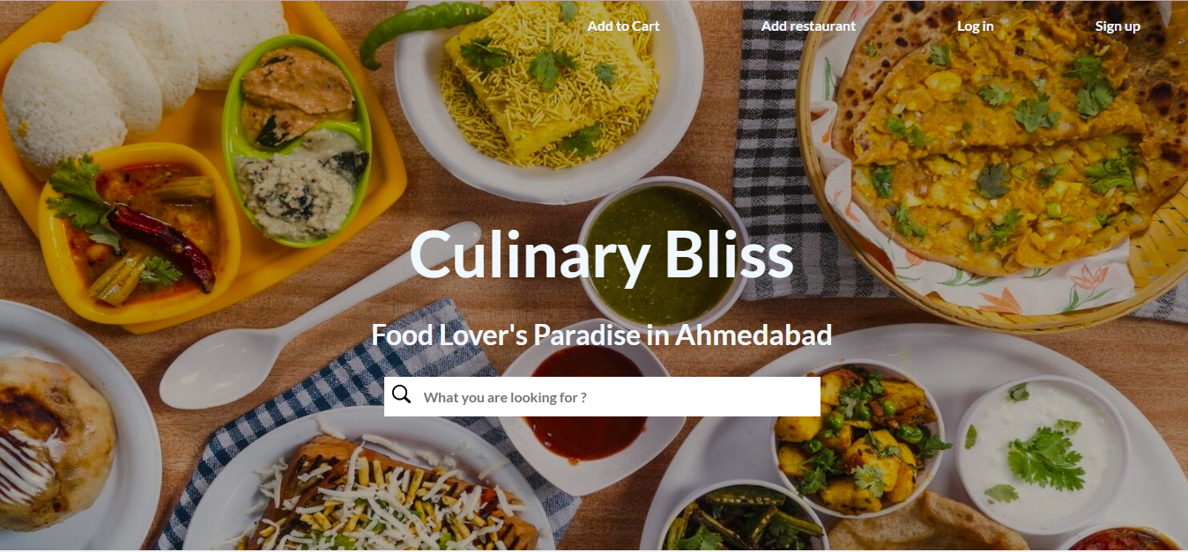

**Page 2**: Next page includes category of food to select

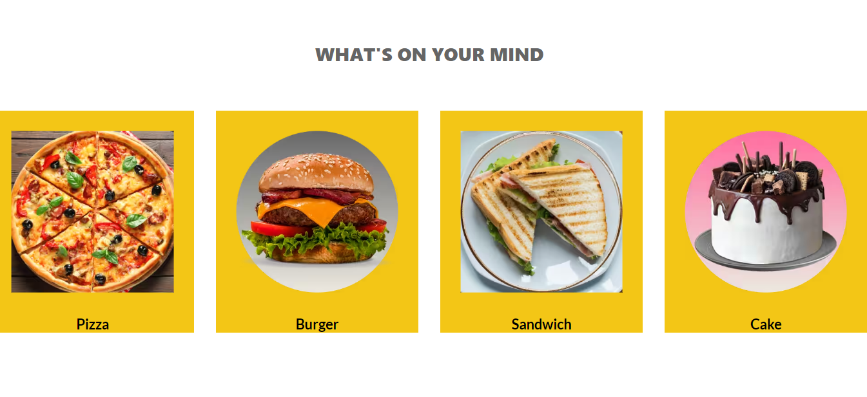

**Page 3:** Next page includes places to select around ahmedabad.

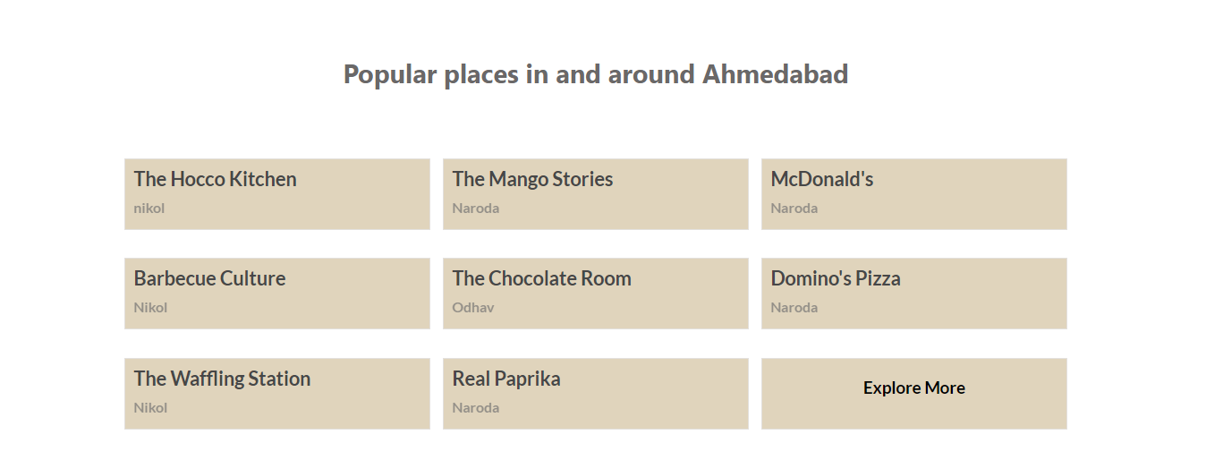

**Page 4**: Next page includes about information about Foody Heaven.

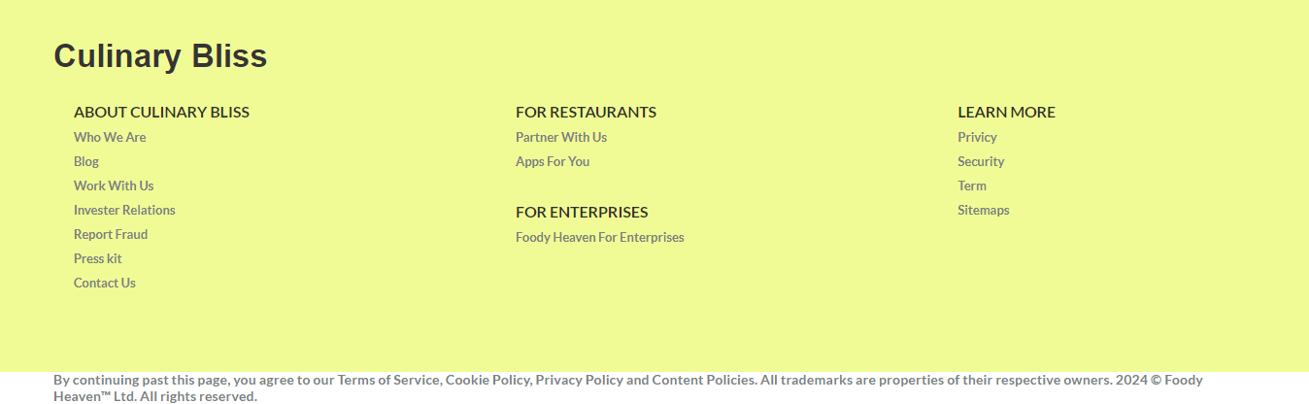

**Page 5**: Next page includes sign up page to create account.

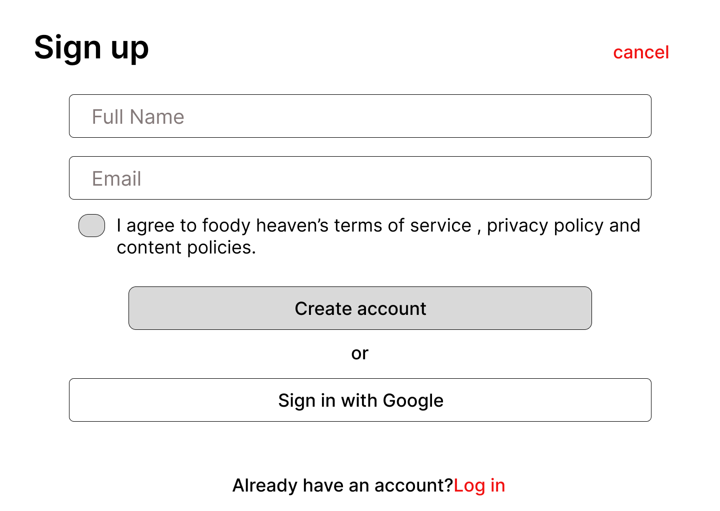

**Page 6**: next page is login page to log in to existing account.

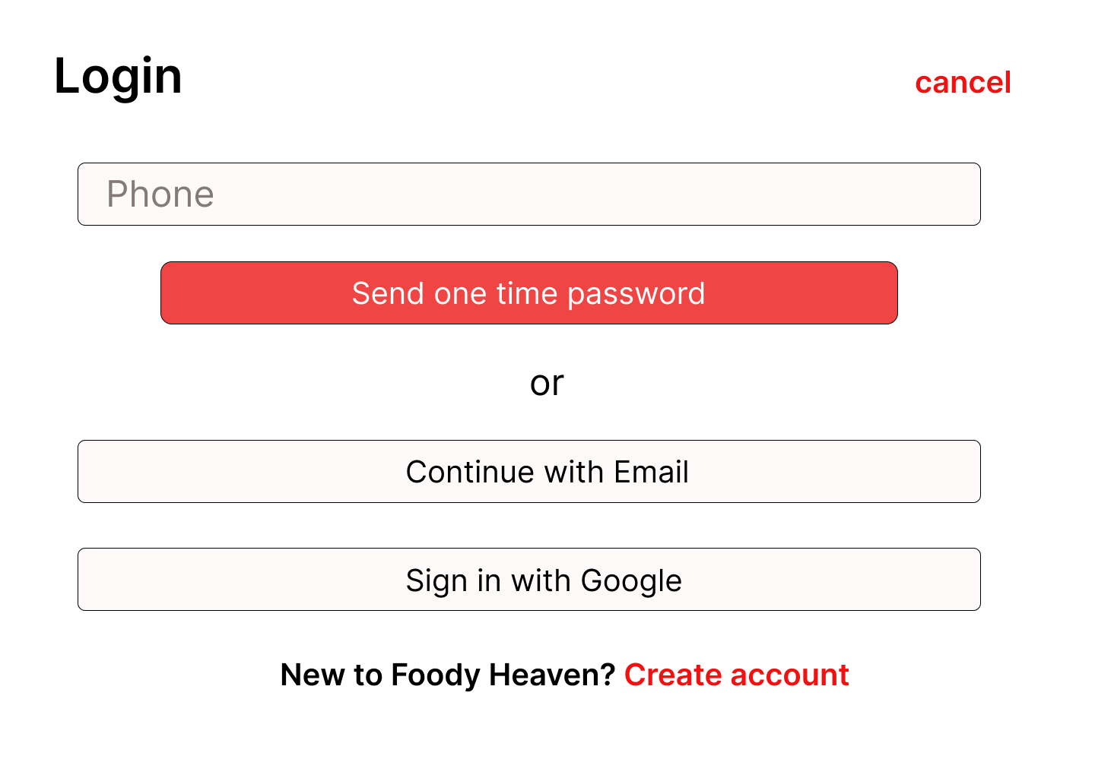

**Page 7**: next page includes options for cake to category of pizza on homepage.

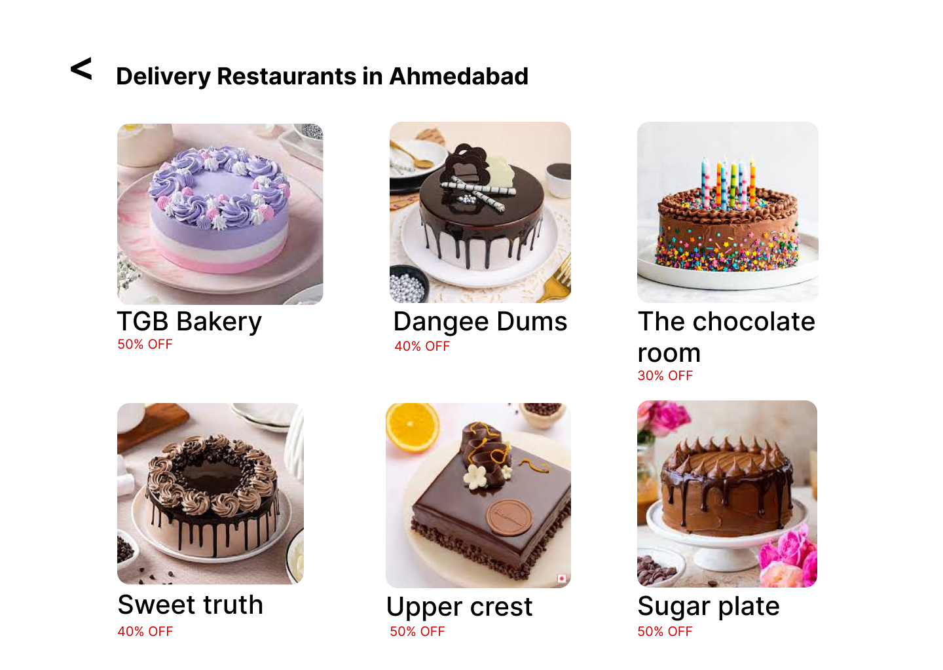

**Page 8**: next page includes options for pizza to category of pizza on homepage.

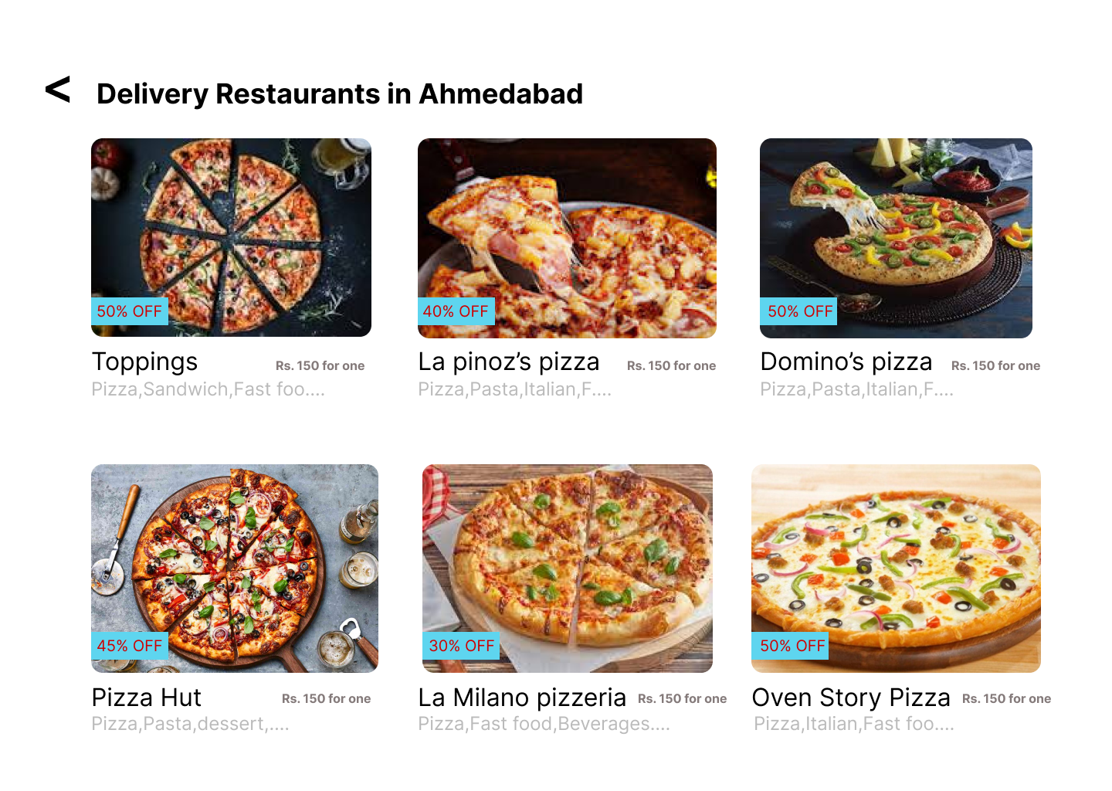

**Page 9:** Next page includes the cart page to cart option.

